**Q1: WHAT IS SDLC ?**

**ANS**: The Software Development Life Cycle is a structured process that enables the production of high-quality, low-cost software, in the shortest possible production time.

.(SDLC), also referred to as the application development life-cycle, is a process for planning, creating, testing, and deploying an information system

**Q2: WHAT IS SOFTWARE TESTING ?**

**ANS**: Software Testing is the activity of checking whether the expected results match the actual results.

. It helps to ensure that the software system is defect free. It helps to identify missing requirements, gaps, or errors that might be contrary to the requirement.

**Q3: WHAT IS AGILE METHODOLOGY ?**

**ANS :**  Agile methodologies aim to deliver the right product, with incremental and frequent delivery of small chunks of functionality, through small cross-functional self-organizing teams, enabling frequent customer feedback and course correction as needed.

.The Agile methodology is a way to manage a project by breaking it up into several phases

**Q4 : WHAT IS SRS ?**

**ANS :**SRS is also known as a Software Requirements Specification is a document or set of documentation that describes the features and behavior of a system or software application.

. SRS forms the basis of an organization's entire project.

. It sets out the framework that all the development teams will follow.

. It provides critical information to all the teams, including development, operations, quality assurance (QA) and maintenance, ensuring the teams are in agreement.

**Q5 : WHAT IS OOPS ?**

**ANS:** Object-oriented programming is a computer programming model that organizes software design around data, or objects, rather than functions and logic.

.Each object can also contain its own procedures or methods.

.Software is designed by using objects that interact with one another.

**Q6 : WRITE BASIC CONCEPT OF OBJECT ?**

**ANS :** Oops in java is to improve code readability and reusability by defining a Java program efficiently.

.The main principles of object-oriented programming are abstraction, encapsulation, inheritance, and polymorphism.

.These concepts aim to implement real-world entities in programs.

**Q7 : WHAT IS OBJECT ?**

**ANS :** These real-world objects share two characteristics: they all have state and they all have behaviour.

.An object is a class instance that allows programmers to use variables and methods from inside the class.

.For example, dogs have state (name, color, breed, hungry) and dogs have behaviour (barking, fetching and slobbering on your newly cleaned slacks).

.Bicycles have state (current gear, current pedal cadence, two wheels, number of gears) and behaviour (braking, accelerating, slowing down, changing gears).

.The software bicycle would also have methods that allowed you to brake, change the pedal cadence and change gears.

**Q8 : WHAT IS CLASS ?**

**ANS :** A class is a group of objects that share common properties and behavior.

.For example, we can consider a car as a class that has characteristics like steering wheels, seats, brakes, etc. And its behavior is mobility.

.A class is a blueprint for declaring and creating objects.

**Q9 : WHAT IS ENCAPSULATION ?**

**ANS :** Encapsulation is defined as the wrapping up of data under a single unit.

.Another way to think about encapsulation is, that it is a protective shield that prevents the data from being accessed by the code outside this shield.

.A part of the code without having to change any other functions or code.

.Encapsulation controls how we access data.

.We can modify the code based on the requirements using encapsulation.

**Q9 : WHAT IS ENHERITANCE ?**

**ANS :** Inheritance is a mechanism in which one class acquires the property of another class

.For example, a child inherits the traits of his/her parents.

.the reception of genetic qualities by transmission from parent to offspring.

.Also take the example of cars. The class 'Car' inherits its properties from the class 'Automobiles' which inherits some of its properties from another class 'Vehicles.

**Q10 : WHAT IS POLYMORPHISM ?**

**ANS :**  Encapsulation refers to the bundling of data, along with the methods that operate on that data, into a single unit.

.A person at the same time can have different characteristics. Like a man at the same time is a father, a husband, an employee. So the same person possesses different behavior in different situations.

.This is called polymorphism.

**Q11 : DRAW USE CASES ON ONLINE BOOK SHOPPING ?**

**ANS :** 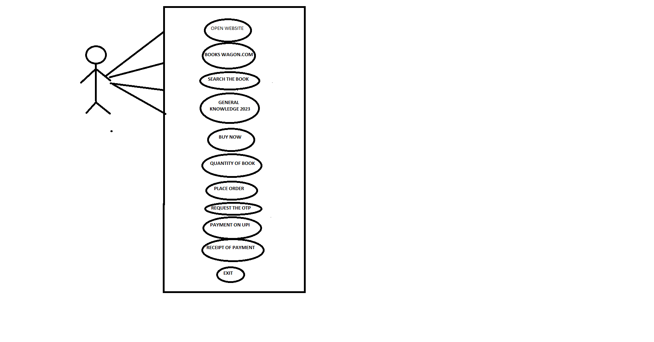

**Q 12 : DRAW USE CASES OF ONLINE BILL PAYMENT SYSTEM [paytm] ?**

**ANS :**

